**Procedure**

**🡪Insert Student Data After Checking All the Validation like email ID, Phone No.**

DELIMITER $$

create procedure StuData(IN first_name varchar(10),IN middle_name varchar(10),IN last_name varchar(10),IN email_id varchar(20),IN age decimal(2,0),IN Contact_Number decimal(10,0),IN event_name varchar(20),IN pg_name varchar(20),IN re_name varchar(20),IN University_name varchar(30),IN degree varchar(10),IN branch varchar(10),IN sem decimal(1,0),IN gender varchar(10))

begin

DECLARE Counter varchar(4);

select count(s_id) into Counter from student;

set counter = counter + 1;

IF email_id like '%@gmail.com' THEN

IF length(contact_number) <=> 10 THEN

IF (select count(University_name) from University u where u.university_name = University_name) then

SELECT 'University Found' AS MESSAGE;

INSERT into student VALUES (first_name,middle_name,last_name,email_id,counter,age,contact_number,event_name,pg_name,re_name,University_name,degree,branch,sem,gender);

SELECT 'YOUR DATA IS INSERTED' AS MESSAGE;

ELSE

SELECT 'Enter Valid Name' AS ERROR;

END IF;

ELSE

SELECT 'Your Mobile No. is not valid' AS ERROR;

END IF;

ELSE

SELECT 'YOUR Email-ID is not valid' AS ERROR;

END IF;

END $$

DELIMITER ;

Call StuData('Raghvendra','D','Gohil','raghav@gmail.com',18,9512100731,'BreakUP Day','Royal Care','Prime Dinning Hall','Dharmsinh Desai','B.Tech','IT',5,'Male');

* In the Student one row is Inserted.

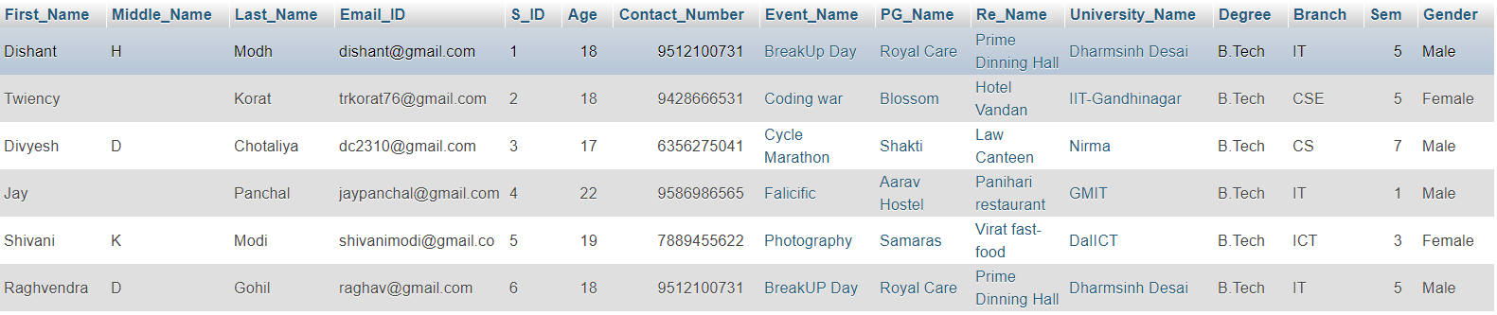

Call StuData('Raghvendra','D','Gohil','raghav@gmail.com',18,9512100,'BreakUP Day','Royal Care','Prime Dinning Hall','Dharmsinh Desai','B.Tech','IT',5,'Male');

🡪As from above query Number Format is not proper so, it will give ERROR.

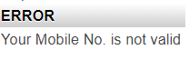

**🡪Show the number of Student in particular University.**

**FUNCTION**

DELIMITER $$

CREATE FUNCTION no_of_student(University_Name varchar(30)) RETURNS int DETERMINISTIC

BEGIN

DECLARE no int;

SELECT COUNT(S_ID) INTO no FROM student s WHERE s.University_Name=University_Name;

RETURN no;

END

$$

DELIMITER ;

SELECT University_Name, no_of_student(University_Name) FROM student GROUP BY University_Name;

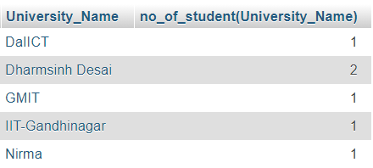

**🡪Show Name Of all Restaurant’s.**

**CURSOR**

DELIMITER $$

CREATE PROCEDURE r1 (INOUT Name_List VARCHAR(1000))

BEGIN

DECLARE done INTEGER DEFAULT 0;

DECLARE r_name VARCHAR(20) DEFAULT "";

DECLARE r_cursor CURSOR FOR

SELECT Re_Name FROM resturant;

DECLARE CONTINUE HANDLER FOR NOT FOUND SET done = 1;

OPEN r_cursor;

list:LOOP

FETCH r_cursor INTO r_name;

IF done = 1 THEN

LEAVE list;

END IF;

SET Name_List = CONCAT(r_name, "-->",Name_List);

END LOOP list;

CLOSE r_cursor;

END$$

DELIMITER ;

SET @Name_List="";

CALL r1(@Name_List);

SELECT @Name_List;

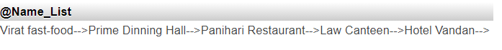

**Trigger**

**🡪Update Event name into Event table and Organize table using Trigger.**

DELIMITER $$

CREATE TRIGGER e1 AFTER UPDATE ON events FOR EACH ROW

BEGIN

DECLARE v1 VARCHAR(20);

SELECT Event_Name INTO v1 FROM events WHERE Event_Name=NEW.Event_Name;

UPDATE `oraganize` SET `Event_Name`=v1 WHERE Event_Name=OLD.Event_Name;

END $$

DELIMITER ;

UPDATE `events` SET `Event_Name`="Dargon Ball" WHERE Event_Name="Coding war";

* After Update on Event Table.

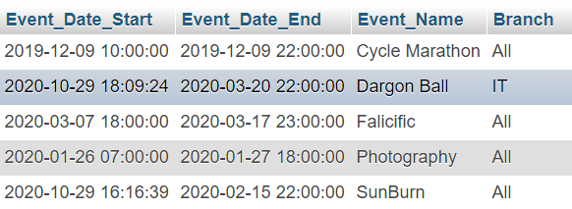

* Updated by Trigger on Organize table.

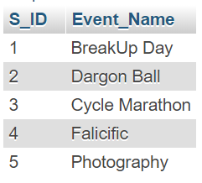

**🡪Delete Community Name from Community Table and Member table using Trigger.**

DELIMITER $$

CREATE TRIGGER c1 AFTER DELETE ON community FOR EACH ROW

BEGIN

DECLARE v1 VARCHAR(20);

SELECT Community_Name INTO v1 FROM community WHERE Community_Name_Name=NEW.Community_Name;

DELETE FROM `member` WHERE Community_Name=OLD.Community_Name;

END $$

DELIMITER ;

DELETE FROM `community` WHERE Community_Name="DSC";

* After Deleting “DSC” from community table

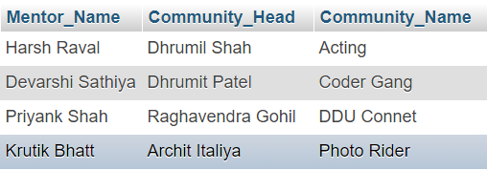

* Deleted “DSC” from Member table using DELETE Trigger

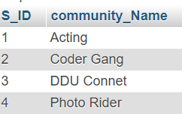

Select * from `student` where `First_Name` like "D%";

SELECT `First_Name`, `Middle_Name`, `Last_Name`,`community_Name` FROM `student` RIGHT JOIN `member` ON student.S_ID=member.S_ID WHERE 1

SELECT `First_Name`,`Middle_Name`,`Last_Name` FROM `university` INNER JOIN `student` ON university.University_Name=student.University_Name WHERE `Location`="Nadiad"

SELECT University_Name , COUNT(Courses_Name) AS No_Of_Courses FROM courses GROUP BY University_Name ORDER BY No_Of_Courses DESC;